**Measuring effect of writing journal and prayer on emotions through brain waves using EEG**

**Introduction**

Mental health is a direct output of human emotions. Human emotions that are sad, angry, frustrated are responsible for affecting the mental health.

While there are many studies on how meditation can reduce these emotions, there is no study on the effect of writing a journal or a diary and prayer has on the human emotions.

This paper will study the effect of human emotions pre and post writing a journal and pre and post saying a prayer.

**Glossary:**

**The different brain waves and their frequency is as below**

|  |  |
| --- | --- |
| Wave type | Frequency |
| Gamma | 30-45 Hz |
| Beta | 14-30 Hz |
| Alpha | 8-14 Hz |
| Theta | 4-7 Hz |
| Delta | 1-3Hz |

**EEG:** electroencephalogram (EEG) is a recording of brain activity

**Previous Literature**

Brain science has shown that human emotions are controlled by the brain [1]. The brain produces brain waves as it transmits messages. Brain wave data is one of the biological messages, and biological messages usually have emotion features. The feature of emotion can be extracted through the analysis of brain wave messages. But because of the environmental background and cultural differences of human growth, the complexity of human emotion is caused. Therefore, in the analysis of brain wave emotion, classification algorithm is very important. In this article, we will focus on the classification of brain wave emotions.

Emotion classification is one of the most important topics in the field of brain Wave Research [2]. One of the main problems in the analysis of brain wave emotion is how to accurately classify the types of emotion. However, the uniqueness and particularity of Brain Potter [3], resulting in the inability to accurately distinguish between the diversity of human emotions. Although the types of human diversity emotions cannot be classified [4]. However, the twentieth century psychologist “Pail Ekmean” divided emotion into basic emotions and complex emotions and basic emotions are closely related to human physiological responses. Therefore, we can classify the emotion types in the basic emotions through the brain Wave Emotion classification method [5].

Pail Ekmean confirmed that basic emotions are human physiological responses [9]. Basic emotions can be divided into six categories, namely, happiness, anger, fear, surprise, sadness and disgust [10]. Psychologists have the following views on basic emotions.

• Fear: The instinctive behavior of a common creature or person in the face of danger in life. Fear can cause changes in the heart rate, elevated blood pressure, night sweats, tremors and other physiological phenomena, and even the symptoms of cardiac arrest shock.

• Anger: Emotional agitation, being violated, disrespected, or wrongly treated, can lead to instinctive self-preparedness for its combat response. Emotional anger, micro lukewarm, resentment, inequality, irritability, hostility, and, more extreme, hatred and violence.

• Sadness: It is usually the psychological frustration of failure, the mood is lower meaning. Emotions are sad, depressed, self-pity, loneliness, depression, despair, and morbid severe melancholy.

• Joy: Emotion is the psychological state of pleasure, with the meaning of joy, contentment,

self-satisfaction, pride, and excitement in the senses.

• Surprise: By unexpected stimulation in the living environment, resulting in temporary

action to stop.

• Disgust: Facing negative stimuli in the environment.

**Evaluation method**

*Method by Petrantonakis et al. [11]*

The method of brain wave instrument used by Petrantonakis et al. is different from other studies. Most of the electrical poles used in the study of brain waves are 64 or channels. The electrode points used in this programme are 3 channels, namely FP1, FP2, and a bipolar channel of F3 and F4 positions according to 10–20 system. In this scheme, the number of electric poles in brain wave instrument For other studies less. That is, the computational complexity of this scenario is low. The purpose of this scheme is to classify

six kinds of human emotions. Six kinds of emotions are: happiness, surprise, anger, fear, disgust and sadness. The programme uses four classification methods, namely quadratic discriminant analysis (QDA), k-nearest neighbor (KNN), Mahalanobis distance (MD) and the Vector Machines (SVMs). The experimental flow is shown in Fig. 1. In this scheme, three methods were obtained to obtain the brain wave eigenvectors (FVS), which were statistical values [12], wavelet transform [13] and higher order crossings (HOC). The FVs classifies six emotions through four classifiers. The experimental results show that SVM has 83.33% average classification rate. The best results obtained by SVM in four classifiers.



Fig 1: Method flowchart by Petrantonakis et al.

**Design of Experiments**

**The subjects**

The subjects are from ages 15 to 60, drawn from various social strata and background. Some were active journal writers and some have not written journals ever.

**Apparatus**

The EEG apparatus used to measure the brainwaves was Flowtime Bio Sensing head band. The Flowtime headband uses two-channel EEG acquisition technology to monitor brainwaves.

**Procedure**

The subjects were asked to first reflect on a unpleasant incident of their lives. After that the EEG machine would capture their brain waves. Subsequently they were asked to write down the incident in a diary. Again the brain waves were recorded. Then the group was asked to pray for other to give them peace from that incident. Post the prayer the brain waves were again recorded.

This was done for a series of 10 days.

The headband would be used to measure the brainwaves of the subject through multiple sessions. The feature extraction was done from the waves for wave amplitude in micro volts.

The brain waves were classified as per the *Petrantonakis* method above to identify the emotions after each stage.

The method used for classification of feature into emotion was KNN.

The available data set on Kaggle was used to classify the emotions.

**Analyses**

Data for alpha and gamma, beta and theta wave patters were collected at 0.5 second intervals for the entire session.

Data from 20 sessions were collected across three months.

The raw data feature extraction was the amplitude of the waves.

**Results**

**After thinking about unpleasant incident**

On an average the emotions classified by the *Petrantonakis* classified as follows

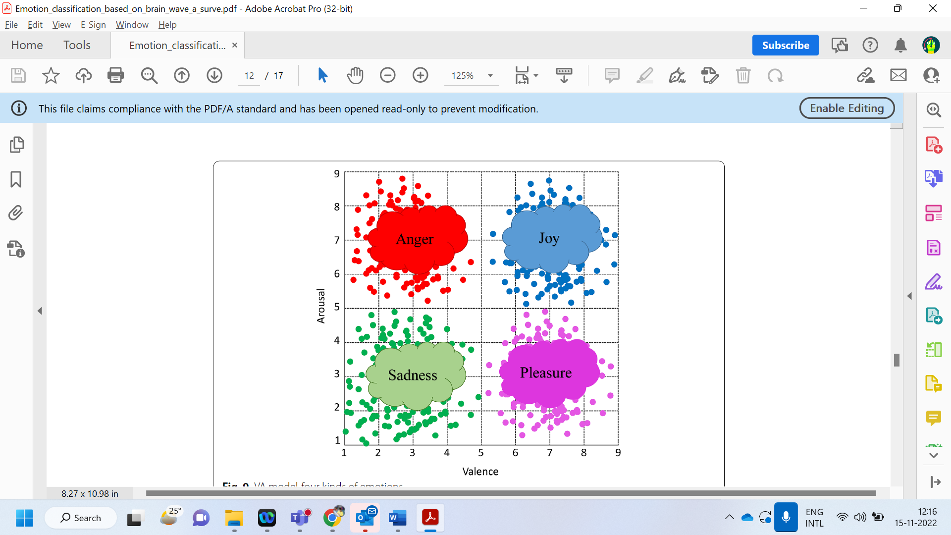

**Fig 2: Emotional classification when remembering the unpleasant incident**

**After writing the journal and praying**

On an average the emotions classified by the *Petrantonakis* classified as follows

**Fig 3: Emotional classification after writing the journal and praying of the unpleasant incident**

**Discussion**

From the EEG output of alpha, beta, theta and gamma waves we can interpret the following:

As soon as the subject remembers or delves on the unpleasant incident of their lives, brain wave activity shows that the emotions felt can be classified as anger and sadness (also clubbed as disgust, depressed)

After the journal was written the emotions based on brain wave activity was classified into happiness positive.

After the prayer was done by the subjects for the other subjects, the emotions based on brain wave activity were classified into happiness and hope.

**Accuracy**

KNN gave the best accuracy of 83%

**References**

1. Liu YJ, Yu M, Zhao G, Song J, Ge Y, Shi Y (2017) Real-time movie-induced discrete emotion recognition from EEG signals. IEEE Trans Affect Comput 9(4):550–562

2. Gupta A, Singh P, Karlekar M (2018) A novel signal modeling approach for classification of seizure and seizure-free EEG signals. IEEE Trans Neural Syst Rehabil Eng 26(5):925–935

3. Jayarathne I, Cohen M, Amarakeerthi S (2017) Survey of EEG-based biometric authentication. In: 2017 IEEE 8th international conference on awareness science and technology (iCAST). IEEE, New York. pp 324–329

4. Ekman P, Friesen WV (1969) The repertoire of nonverbal behavior: categories, origins, usage, and coding. Semiotica 1(1):49–98

5. Zheng WL, Zhu JY, Lu BL (2017) Identifying stable patterns over time for emotion recognition from EEG. IEEE Trans Affect Comput 10(3):417–429

6. O’Regan S, Faul S, Marnane W (2010) Automatic detection of EEG artefacts arising from head movements. In: 2010 annual international conference of the IEEE engineering in medicine and biology. IEEE, New York. pp 6353–6356

7. Lan Z, Sourina O, Wang L, Liu Y (2016) Real-time EEG-based emotion monitoring using stable features. Vis Comput 32(3):347–358

8. Mohammadi Z, Frounchi J, Amiri M (2017) Wavelet-based emotion recognition system using EEG signal. Neural Comput Appl 28(8):1985–1990

9. Ekman P (1999) Basic emotions. Handb Cogn Emot 98(45–60):16

10. Ekman P, Friesen WV, Ellsworth P (2013) Emotion in the human face: guidelines for research and an integration of findings, vol 11. Elsevier, Burlington

11. Petrantonakis PC, Hadjileontiadis LJ (2009) Emotion recognition from EEG using higher order crossings. IEEE TransInf Technol Biomed 14(2):186–197

12. Takahashi K (2004) Remarks on emotion recognition from bio-potential signals. In: 2nd international conference on autonomous robots and agents, vol. 3. pp 1148–1153

13. Murugappan M, Rizon M, Nagarajan R, Yaacob S, Zunaidi I, Hazry D (2007) EEG feature extraction for classifying emotions using FCM and FKM. Int J Comput Commun 1(2):21–25